Task 1: Analyse the problem
To support the teachers of junior learners, your task in this assessment activity requires you to undertake technological practice to develop a Basic four function GUI calculator.
Task 2: Identify the input information
What information will the user have to enter? Copy and complete this table.
Variable name | Format | How entered
number | String (global variable) | Button click, key press
Task 3: Identify the output information
What information will the program need to print out? Copy and complete this table.
Output | Format | When it happens
equationAns | String (global variable) | When equals button pressed
number | String (global variable) | When button clicked, key pressed
Task 4: Identify the stored information
What information will the program need to store? Identify any constant values, if necessary.
Variable | Format | Equals
text | Entry (global variable) | Display box
status | Label (local variable) | Status bar
numCol | Integer (local variable) | 0
numRow | Integer (local variable) | 1
numList | List (global variable) | All buttons
operatorButtons | List (local variable) | All operators
possibleKeys | List (global variable) | All key binding names

Task 5: What calculations are necessary
Write out the calculations in terms of the variables specified above.
Evaluate equationList variable.
When button created, add one to column.
If column equals 4, add one to row and reset column to 0.
Task 6: Test Data table of expected inputs
Create a table of expected input data using Excel or Word.
Input | Output
Press button (0-9, operators) | Number/operator added to entry widget
Press equals button | Outputs answer to equation in entry widget
Press delete button | Clear everything in entry widget
Press cancel button | Last thing added to entry widget clears
Press exit button | Calculator GUI closes

Task 7: Deskcheck of steps used in processing
Create a deskcheck showing how the output will be obtained. This could be with printed table and pen or in Word or by formula printout in Excel; and add the result to your document.
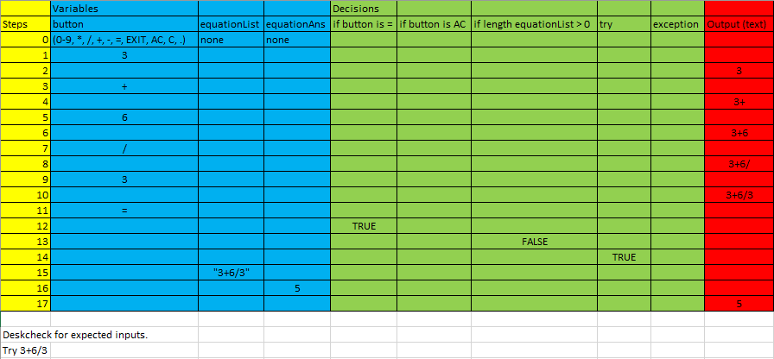

Task 8: Create a testing procedure
Describe the steps that the computer program will have to take to solve the problem. You may choose to do this as pseudocode or as a flowchart. You must clearly identify sequence (steps in order), selection (choice of actions) and iteration (looping or repetition).
You are recommended to develop several versions of your plan showing how you will continually improve and refine your program to solve the given task. The final version in your testing procedure should clearly show how the program will solve the given task on expected data inputs.
Make any additions to the input, output and storage tables that are necessary as you refine your plan to solve the problem.

Algorithms (See Attached):
-Delete Number
-Clear Number
-Button Pressed
-Text Update

Task 9: Create a testing table for boundary inputs for testing the program
Add to your test data table to indicate what boundary inputs you would include for testing the program
Clearly indicate in a new version of your plan what extra steps may be needed in your program to ensure the sequence of actions correctly performs the task and has no unintended behaviour or consequences.

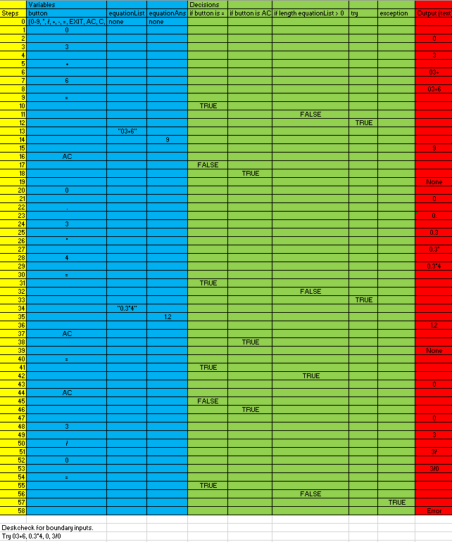

Task 10: Create a testing table for invalid inputs for testing the program
Add to your test data table to indicate what invalid inputs you would include for testing the program comprehensively.
Clearly indicate in a new version of your plan what extra steps may be needed in your program to make a robust and flexible program.

